Chapter 10, Solution 36.

Consider the circuit below.
j4 
2 
-j3 
490 A
120 V
+
−
2 
2 
20 A
+
V_{o}
−

I₃
I₂
I₁
Clearly,
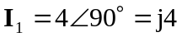 and 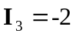

For mesh 2,
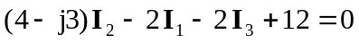
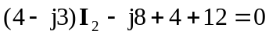
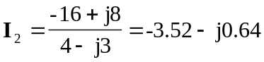

Thus,

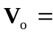 11.64852.82 V

